**Virtual Music Festival Website**

I have chosen the virtual music festival event to promote and on through the website content and flow I have mentioned all the activities and the events of the virtual music festival. As this the era of technology and meta-verse is going to be inn in our environment so the people are more comfortable with the internet and virtual events that’s why I chose to make website on the virtual music festival.

**Flow of the content:**

* The first page and the headings are so effective to the content so I have mentioned about the virtual music festival in the heading of the page.
* Then the date is important as well as the why the virtual event is important and why people prefer it, those points are in the front. And the date is prominent and clearly visible so that the audience are clear about the event date.
* All the guests, singer and performances are mentioned clearly that what type of the event will and who is going to be there to perform what will be the festival themes.
* To buy ticket there is a tag on the top from where they can buy the tickets and the timings will be on the tickets with schedule of the festival.
* The images and the color scheme is attractive so that audience will attract towards the festival.

**Why to chose the virtual music festival event and how to make it better?**

* Making sure everyone is on the same page requires rigorous tech testing and line-up rehearsal. To ensure a smooth performance, you should decide in advance how many songs each artist will perform.
* Choosing a lineup in the style of a festival with other performers may encourage you to seek out other artists in the same genre or you may decide to mix it up. For example, do you host rock concerts? Or will it be a fusion of regional bands and musical genres?
* Asking someone to serve as the festival's MC or host can be a smart move. It may be a member of the family, a local DJ, or even a famous person. They are able to oversee and plan for it will feel much more professional if the lineup is handled, any questions are answered, the artists are introduced, and the concert is opened and closed.
* Treat the gathering as though it were a genuine celebration. Making a brand image that people will buy into starts with a memorable name, logo, and mood.
* Keep in mind that a festival is just as much about the atmosphere as it is the music. As a result, you want attendees to feel involved and present at the event.
* Use your friends, family, followers, and nearby companies to generate buzz. Make contact with everyone you know and make sure that each artist informs their networks about the event. To maximize ticket sales and/or viewings, this must be done at least a week before to the event.

**Website flow:**

* There is header bar having all the options of the website what are the main information provided here about the website like home, about guests, events and other. Here is a logo of the Bright light Music at the left top corner which is attractive and gives you the feel about music.
* The website is multipage like the FAQ’s Events and the details of the events like detail about the theme of the festival and the stage of the festival. To provide the realistic view to audience and live concert feeling these things are mentioned and arranged.
* On scrolling down all the details like singers and festival events details are mentioned in a mannered and stunning way with image of every concerned detail to give the clear view of the festival to audience.
* Different CSS techniques are used to give the attractive look to website like in website there is upcoming events heading and the images of it so the following properties are coded in it:

.gallery .row{

    display: grid;

    grid-template-columns: repeat(auto-fit,minmax(30%,1fr));

    gap: 0.1rem;

    padding: 0.7rem;

}

The grid and grid-template-columns is used to display the images in a grid form and aligned properly with the same height and width of their own div’s. Proper padding and gaps are used for the attractive view of the images.

* The html used for the nav-bar at the top of the website is made by the following code:

<nav class="navbar">

            <a href="#home">home</a>

            <a href="#about">about</a>

            <a href="#services">Guests</a>

            <a href="#gallery">Events</a>

            <a href="#team">Sponsers</a>

            <a href="contact.html" target="_blank">contact</a>

            <a href="">Get Tickets</a>

            <a href="faq.html" target="_blank">FAQ's</a>

        </nav>

The anchor tag is used for it so that we can perform the on click events like when we click in the FAQ’s the FAQ’s page is opened and in the new window as the target is blank. And this is done for the all other anchor tags. In head ref tag “href” where there is #about like this is like the table of content when we click on it our page automatically scrolls on that given id where the about div or id is mentioned and starts.

* For login page the form tag is used in html for filling the login details.

        <form action="" class="login-form">

            <h3>login now</h3>

            <input type="email" placeholder="enter your email">

            <input type="password" placeholder="enter your password">

            <input type="submit" value="login">

        </form>

Here in the form input tags are used which is used for taking the value from the user and then use that value at our concerned place. In input there are several types of the input type like if we want to enter the password the value of the password will automatically hide while type and similar like if we use email type other than the email input there will be error and this will not allow you to proceed further.

* For event details there is an other page which is linked with a button created above the sponsors the div is created having the image at the background and some content in front.

   <div class="chose">

        <div class="content">

            <h1>Events of the festival</h1>

            <p>There will be several events in our virtual music festival.</p>

            <a href="EventsDetails.html" class="btn">Click here for Events details</a>

        </div>

    </div>

.chose{

    margin: 15rem 0;

    background: linear-gradient(rgba( 0, 0, 0, 0.6), rgba(0,0,0,0.7)),

        url(../Solar-Sounds-Festival-Polar.jpg) center no-repeat;

    background-attachment: fixed;

    height: 40rem;

    width: 100%;

    text-align: center;

    display: flex;

    align-items: center;

    flex-direction: column;

    justify-content: center;

}

.chose h1{

    font-size: 3.5rem;

    color: var(--min-color);

}

.chose p{

    font-size: 2rem;

    margin: 1rem;

    color: var(--min-color);

}

The html and CSS is mentioned above which is used for making that div and providing the functionality. The address of the file of events details is typed in href so that when the anchor tab will be pressed the event details page will rendered and open. In CSS the flex attribute is used which will display the content in flex form or we can say that horizontally aligned.

* For login form the java script is used so that when we click on the icon of the login the form will appear and then when will enter the data the data will be sent to the browser.

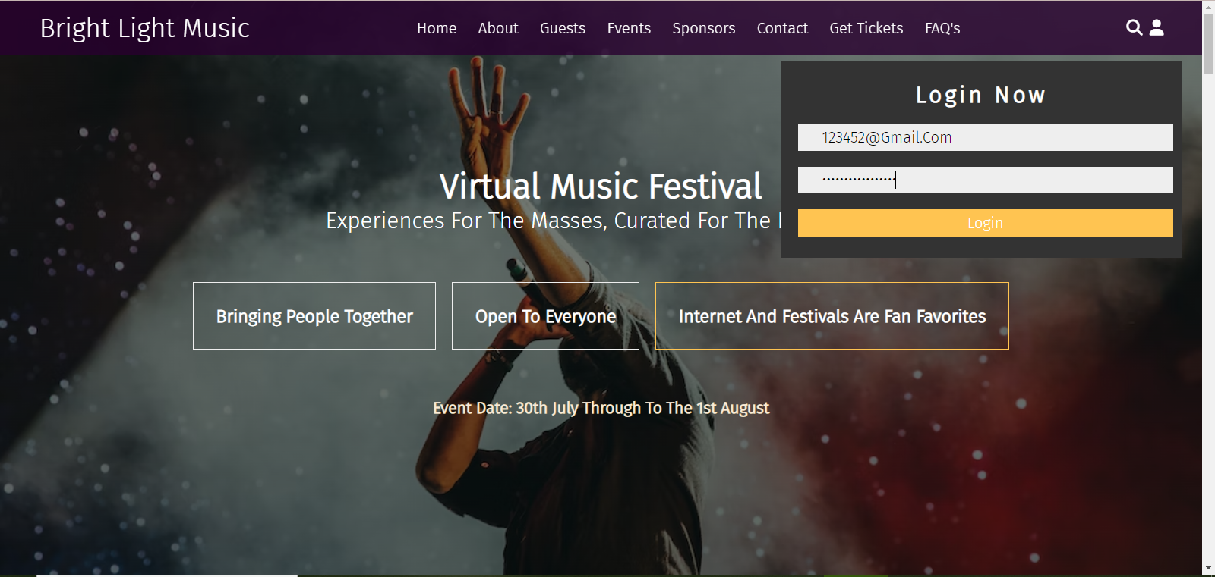

Figure 1 Login form

Here is the code of java script of the login form.

let loginForm = document.querySelector('.login-form');

document.querySelector('#user-btn').onclick = () =>{

    loginForm.classList.toggle('active')

    Navbar.classList.remove('active');

    SearchForm.classList.remove('active');

}

When we click on the icon of login the id is passed to the script written and onClick event happens which means the form appears and after clicking again on the icon the form disappears which is done by the .remove function. The id is passed to the .toggle and .remove which means when we click the icon the mentioned id is used for functionality.

**Conclusion:**

The website is about the virtual music festival and it is the promotion website which will be used for marketing purpose of the festival. The website is responsive and attractive which is the main agenda to attract the audience attention. The ticketing details are also mentioned and all the flow of the festival and events held in festival are mentioned. Proper HTML, CSS and Java script is used for best visualization of the website. Website is of multiple page and FAQ’s are also included in it which will guide the audience about the procedure of entering in the festival.